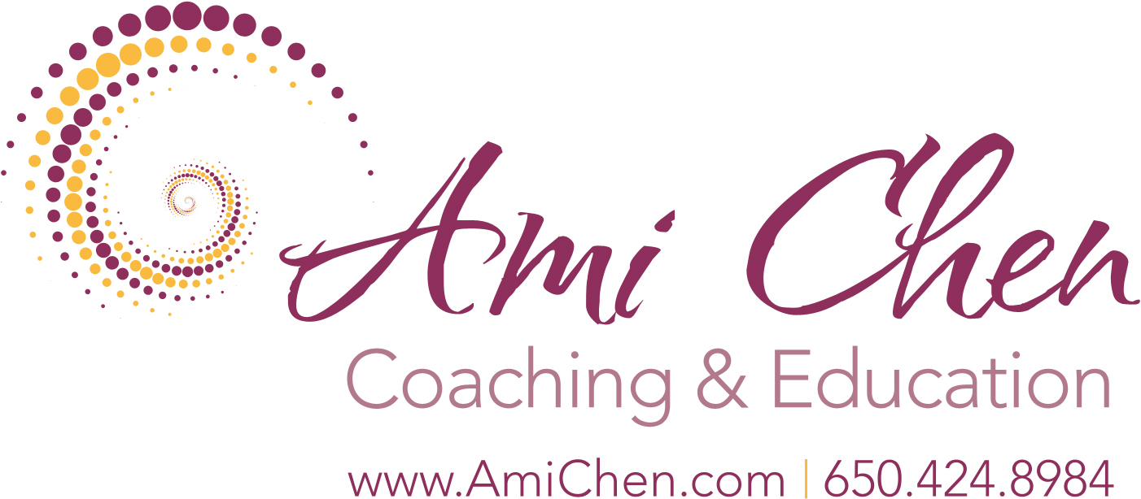

Resources

Ami Chen … (Full Name: Ami Chen Mills-Naim)
www.AmiChen.com
Facebook: Ami Chen Coaching and Education
Facebook Group: (around education and parenting) State of Mind and the Spark Inside
Twitter: @AmiChenCoaching

Books: The Spark Inside: A Special Book for Youth, Lone Pine Publishing and international … (Swedish & Russian translations coming soon, Orthodox Jewish/younger childrens’ version available from Tikun in London)

State of Mind and the Spark Inside: Thought, Consciousness and the Essential Curriculum for Healthy Learning, CPLI, Spark Inside Imprint, Berkeley & Amazon. (Italian translation coming soon)

Spiritual Maturity: Dialogues and Freedom and the Formless, coming in 2017 from Create Space/Amazon

Programs
Family and Individual Coaching & Mentoring, in person, Skype or Zoom; Private Retreats, Public Retreats, Distance Learning Program and Year Long Facilitator Training for 2017, please contact info@amichen.com or register for newsletter

Also Recommended: Works of Sydney Banks, Gangaji and Toni Packer
Three Principles General: Many Facebook groups & websites … Check “3 principles of mind, consciousness and thought” as a start …
Also: 3pgc.org and threeprinciplesmovies.com

