Check & Connect, an Evidence-Based Student Engagement Intervention
Presentation at the Des Moines School Culture & Climate Summit August 2016

Presenter contact information:

Kay A. Augustine Shelli Blazic
Iowa Department of Education Great Prairie Area Education Agency
515-725-1182/515-326-5620 (319) 753-6561 Ext. 1133/(319) 750-7215
Kay.augustine@iowa.gov shelli.blazic@gpaea.org
For opportunities for Check & Connect training in Iowa, please contact your AEA PBIS Coordinator.

Check & Connect is a project of the Institute on Community Integration at the University of Minnesota.
Visit www.checkandconnect.org for more information
Materials presented on the foundational components of Check & Connect come from the following publication:
Christenson, S. L., Stout, K., & Pohl, A. (2012). Check & Connect: A comprehensive student engagement intervention: Implementing with fidelity. Minneapolis, MN: University of Minnesota, Institute on Community Integration.

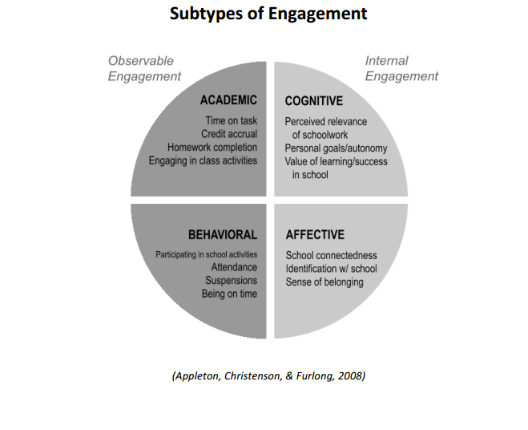
Table 4.4. Advice to Potential Teacher Mentors from Experienced Teacher Mentors
Focus area | Advice from Teacher Mentors in this study
1. Time | “First thing is how much time do you have? It’s a big time commitment if you’re going to do it right.”
2. Limit the number of  mentees you take | “I would say maybe just do one to start just to really give it the time…just one to start and then if it’s going well, add more.”
3. Be an experienced  teacher first | “As a new teacher you are going to be overwhelmed. “ “Be in the classroom for a few years and kind of understand the background of the kids and have a good handle on the curriculum, because this is time-consuming.”
4. Be realistic | “Are you prepared to accept that you might not feel like you’re making a difference? You won’t automatically get the feeling that you’re saving the world.”
5. You have to want to do it | “Definitely do it if being a mentor to kids is something you care about.”
6. Don’t be afraid | “Don’t be afraid to put in the time. Don’t be afraid to give a piece of yourself to the kids and just be there for them, not just academics, but as a support system.”
7. Believe in them | “Hold high Expectations. Don’t back down on them just because they are your mentee student. Make sure that you realize that these students can be successful.”
8. Empower them | “Help kids build the skills that they need to succeed later in life. Don’t just be a crutch to them. Help them figure out the answers, but teach them ways that will carry on longer than you are their mentor.”
9. Be positive and be there | “No matter what, even though it’s frustrating or they’re not responding…Be available and be patient.”
10. Celebrate the small  successes | “Even if one day you see a change, consider the little triumphs, those little things that just make the world go round. It can be chaotic for 10 minutes and then, all of a sudden, you look and they are working and you’re like, sweet!”
Augustine, K., (2014). Teacher mentors: Lived experiences mentoring at-risk middle school students. (Doctoral dissertation). Escholarshare/drake.edu.(dd2014KAA.pdf).

Kay’s Baker’s Dozen of Tidbits for Mentors

1. | Show that you authentically believe in the potential of all youth
2. | Fear is real, and vicious
3. | They can’t do what they don’t know
4. | Don’t do for students anything which they are able to do for themselves--but remember #3
5. | Listen into voice –listen with more than your ears
6. | Modeling speaks louder than words—and they will be watching you “like a hawk”
7. | Highlight the small successes not only for your student(s) but for yourself and other mentors
8. | Hold all student to high expectations
9. | Know your biases and how to monitor if they are impacting your work with your student(s)
10. | Respect and follow rules & policies
11. | Teach your student(s) how to ask effective questions & probe more deeply
12. | Don’t pass your stress on to your student(s)
13. | Build an ethical learning community with your Coordinator & other mentors—practice “carefrontation”  © Augustine 2012
Planning for Intentional Meetings with your Mentee

- OPENER—the first minutes can be uncomfortable for the student and/or the mentor—consider ways that you can make getting into a conversation low risk, for example:
  - Have a fishbowl with slips of paper that the student can “draw”—each slip has a different question or topic that can start the conversation (ex. , Best thing that happened this week, what color would represent how you feel today, etc.)
  - Use Story Cubes for the student to tell you the “story” of how their day/week is going
  - Use erasable dice with trigger questions—the student can “roll the dice” and answer the question(s) that come up

- CONTEXT—the opener may or may not lead into the conversation you need to have—To create a context for your conversation:
  - provide a brief explanation of why you want/need to talk about a specific issue or do a specific activity (ex., the semester is ending and we need to discuss where you are with your current course work and what you want to take next semester; today is the day we scheduled to review your quarter goals, etc.)
  - Be aware that the opener may bring to light needs of the student that usurp your planned conversation.
  - Stay flexible so the needs of the student drive your relationship while also keeping the focus on moving the student to successful engagement at school and with learning.

- DIALOGUE—Capacity-Building/Problem-Solving
  - Use the 5-step (from manual) or STAR strategy to identify options and actions to address any issue, challenge or problem
(STAR=Stop, Think (choices, consequences, commitment), Act, Reflect)
  - Use this time to help the student review and reflect on their monitoring data and goal-setting

- CLOSER—Watch to be sure you have time to purposefully close your time together. Create a tradition with your student for closing your time together, for ex., a high-five, a phrase or statement like “make your day a good one”, etc.

© Augustine 2012

