Moore Handouts
From Dr. Eddie Moore, Jr. © America & Moore, LLC

If I love you,
I have to make you conscious of the things you don't see.
- James Baldwin

An understanding of White Privilege ultimately unmasks a dirty secret kept hidden by White Americans: much of what they have attained is unearned, and even if they are not overtly racist, Whites cannot choose to relinquish benefits from it.
- Derald Wing Sue

TEN THINGS EVERYONE SHOULD KNOW ABOUT RACE
Our eyes tell us that people look different. No one has trouble distinguishing a Czech from a Chinese. But what do those differences mean? Are they biological? Has race always been with us? How does race affect people today? There's less - and more - to race than meets the eye:
1. Race is a modern idea. Ancient societies, like the Greeks, did not divide people according to physical distinctions, but according to religion, status, class, even language. The English language didn't even have the word 'race' until it turns up in 1508 in a poem by William Dunbar referring to a line of kings.
2. Race has no genetic basis. Not one characteristic, trait or even gene distinguishes all the members of one so-called race from all the members of another so-called race.
3. Human subspecies don't exist. Unlike many animals, modern humans simply haven't been around long enough or isolated enough to evolve into separate subspecies or races. Despite surface appearances, we are one of the most similar of all species.
4. Skin color really is only skin deep. Most traits are inherited independently from one another. The genes influencing skin color have nothing to do with the genes influencing hair form, eye shape, blood type, musical talent, athletic ability or forms of intelligence. Knowing someone's skin color doesn't necessarily tell you anything else about him or her.
5. Most variation is within, not between, "races." Of the small amount of total human variation, 85% exists within any local population, be they Italians, Kurds, Koreans or Cherokees. About 94% can be found within any continent. That means two random Koreans may be as genetically different as a Korean and an Italian.
6. Slavery predates race. Throughout much of human history, societies have enslaved others, often as a result of conquest or war, even debt, but not because of physical characteristics or a belief in natural inferiority. Due to a unique set of historical circumstances, ours was the first slave system where all the slaves shared similar physical characteristics.
7. Race and freedom evolved together. The U.S. was founded on the radical new principle that "All men are created equal." But our early economy was based largely on slavery. How could this anomaly be rationalized? The new idea of race helped explain why some people could be denied the rights and freedoms that others took for granted.
8. Race justified social inequalities as natural. As the race idea evolved, white superiority became "common sense" in America. It justified not only slavery but also the extermination of Indians, exclusion of Asian immigrants, and the taking of Mexican lands by a nation that professed a belief in democracy. Racial practices were institutionalized within American government, laws, and society.
9. Race isn't biological, but racism is still real. Race is a powerful social idea that gives people different access to opportunities and resources. Our government and social institutions have created advantages that disproportionately channel wealth, power, and resources to white people. This affects everyone, whether we are aware of it or not.
10. Colorblindness will not end racism. Pretending race doesn't exist is not the same as creating equality. Race is more than stereotypes and individual prejudice. To combat racism, we need to identify and remedy social policies and institutional practices that advantage some groups at the expense of others.

Created by: RACE - The Power of an Illusion, produced by California Newsreel in association with the Independent Television Service (ITVS). Major funding provided by the Ford Foundation and the Corporation for Public Broadcasting Diversity Fund. © 2003 California Newsreel.

Words Matter – Definitions to Consider
Racial Stereotype: An image, attitude or judgment, applied to an entire group of people.
Race: A social construct (with no biological validity) that divides people into distinct groups by categorizing them based on arbitrary elements of physical appearance, particularly skin color.
Power: Access to individuals, social groups, and institutions that own and/or control the majority of a community's resources, as well the ability to define norms and standards of behavior.
Prejudice: An attitude or opinion—usually negative—about socially defined group (racial, religious, national, etc.) or any person perceived to be a member of that group, formed with insufficient
knowledge, reason, or deliberation.
Racism: Most people use the word "racism" the way they used the term "prejudice." But anti-racist activists see racism as "race prejudice PLUS power," in other words, discrimination based on racial
stereotyping (conscious or unconscious, active or passive) that is backed by significant institutional power (race prejudice + power = racism).
Institutional Racism: The ways in which institutions—social, political, educational, financial, religious, medical, housing, jobs, criminal justice—create and/or perpetuate systems that advantage white people at the expense of people of color.
White Privilege: Unearned advantages that benefit whites (whether they seek such benefits or not) by virtue of their skin color in a racist society.
White Supremacy: Once used only by racist groups such as the Ku Klux Klan, the word is also used in anti-racism work to describe the historically based, institutionally perpetuated system of domination
and exploitation of people of color by white people, and which maintains white peoples’ position of relative wealth, power, and privilege.
"Reverse Racism": A term commonly used by white people to equate instances of hostile behavior toward them by people of color with the racism people of color face. This is a way of ignoring the issue of who has the power.
Internalized Racism: The conscious or subconscious acceptance of the dominant society’s racist views, stereotypes and biases of one’s ethnic group, leading to finding fault with oneself or members of one's own group, while valuing the dominant culture (internalized inferiority). Another form of internalized racism is when a white person mistakenly believes s/he is better than people of color ( internalized superiority).
"Non-racist": Term used by those who consider themselves "color-blind," a claim that in effect, denies any role in perpetuation systemic racism, or any responsibility to act to dismantle it. Institutional
racism is perpetuated not only by those who actively discriminate, but also by those who fail to challenge it (silence = consent).
Anti-racist: An anti-racist is someone who makes a conscious choice and persistent effort to challenge white supremacy, including her/his own white privilege, and to actively oppose forms of discrimination against people of color.
These definitions are based on definitions originally created by the Challenging White Supremacy
Workshop - cwsworkshop.org.

Distancing Behaviors Often Used by White People
By James Elder & Bruce Irons

Many of us use distancing behaviors- things that separate us from the issues at hand, in an effort to avoid dealing with a very painful subject such as racism. This sheet includes some of those behaviors that we often use against each other to the detriment of dealing with racism.

1. Definitions Game: Requests for clear, absolute definitions of racism or related terms. Usually leads to involved discussion. Not to be confused with actual need to clarify differences among concepts like racism, discrimination, prejudice, etc.

2. Where are the People of Color: Assuming/insisting that in order to make progress combating personal racism we must be in a discussion with people of color. Combined with this is the idea that there are no or few third world people in a given community, that racism isn’t a problem. (In fact, racism may be such a great problem that few Third World people can stand to live there.)

3. Racism isn’t the only problem: Assuming/insisting that racism is only a facet of a larger problem, or that we cant just deal with it, we have to talk about how we are hurt too etc. while it is true that there are other oppressions, this is often a resistance to dealing with and focusing on racism.

4. Being an Expert: Being an expert on the experience of another race or culture and on how to deal with racism, the “I’m the okay white person in the group” distinction. This leads to intellectualizing and not dealing with the ongoing need to change.

5. Instant solutions: Oversimplification by choosing and pushing single solutions to racism may be a kind of avoidance and might, even if sincere, be unproductive because it is not looking deep enough.

6. Find the Racist: Rather than acknowledge that we all are racist by socialization and all white people benefit from racism, including oneself, it can be easy to focus on the person in the group who may be more open about her racism, or have thought the least about it. Regardless of how much we have done, we still have more to learn.

7. After I…: Focusing on all things that prevent oneself from acting right now to challenge racism. It will be done when…(some magic occurrence).

8. Geography: Focusing on places with the reputation for racism, rather than looking to discover how racism is affecting your own community. For instance, in the sixties, everyone thought the racism only existed in the South, now many of us think that it only exists in Boston or in a place where there is a visible third world presence. This is not necessarily true. In a white dominated society, there is racism
everywhere.

9. You’ve come a long way…: Focusing on what changes have or may have occurred since people of color began the recent struggle for civil rights then liberation, as though to suggest that they should be satisfied. Though we should acknowledge victories have been won, it is important not to discount what is left to be done.
from Beyond Heroes and Holidays: A Practical Guide to K-12 Anti-Racist, Multicultural Education and Staff Development (2007) edited by Enid Lee, Deborah Menkart and Margo Okazawa-Rey
Effective Speaking Up Strategies

Show empathy, even as you share how the person's words hurt you: I know you like Ramon, but it hurts me when you call him Romaine. How would you like it if I called your mother by a nickname?

Asking what experiences or sources the person is basing his/her opinion on, so that you can discuss specifics, not generalizations.

Share relevant facts, if you know them: "There's a history of Anglos calling Latino agricultural workers "lettuceheads" - it's a slur as bad as "wetbacks." "I remember a study that showed that Black people overtip because they're so aware of their reputation."

Try to reach the person's heart and mind: acknowledge others' experiences, and share your own: "That's your experience, but I've never had a problem in Roxbury: in fact, people have gone out of their way to be helpful."

Start with the positive: "I know you like him" (Ramon) so..."

Make clear, especially to a friend, relative, or colleague, that you're talking about a particular behavior, not the person: "I like everything about you except when you say "....."

Check your understanding of the other person's view, to pinpoint where you agree, or not: "OK, so it sounds like you're saying that you believe institutional racism does exist, but you also think that people of color too often see racism where it doesn't exist?"

If you don't have the facts, share the need to find them: "I'd like to look up the stats on that and get back to you - let's talk again."

Be willing, if you worry that you'll be unprepared for a person's counter-arguments, to say simply "I don't have an answer for that, but I still feel strongly that..."

Name the emotional effect of a remark that the other person sees as trivial or a joke: "It's upsetting to me."

Distinguish intent from effect: "I'm not calling you a racist, and you may not have intended your remark to be racist, but it comes off that way."

Explore the root causes of a situation: "I think it may be more complicated than that -- why do you think that happened?

Use words like maybe: "Maybe we need to change things about the way we do things in our church so that it's more welcoming to people of color."

Ask "ever wonder"questions: "Ever wonder why the city neighborhood doesn't want to join our summer suburban kids program anymore?" or "I wonder why our church IS all white - why do YOU think it's all white?"

Challenge the person's view by extending it: "So if giving extra points to college candidates of color is unfair, would you also stop colleges from giving extra points to children of alums, extra points to ensure geographic diversity, or extra points to vets? Because colleges have always done that."

Suggest an action: "Ever tried saying hello to those Black kids hanging around in front of the building? Yes, you think they hold anti-gay or anti-white resentments, but they may be thinking "Why doesn't this guy talk to us - is it because we're Black?"

Offer to help: "You can't remember how to pronounce "Ramon"? Just think of the group the Ramones and leave off the "es" or "I'd like you to recruit Black candidates for the job opening, and I'll help with it."

Don't let labeling/dismissive terms deter you: if you're labeled "politically correct," restate your belief clearly: "Political correctness" is a label. I'm talking about fairness, treating people equally, humanity."

Name real consequences: "I like visiting, but if you won't stop calling him "Romaine," I will stop coming home. I need my boyfriend to feel comfortable here."

Show that the issue is important enough to discuss further at a better time: "What you're saying bothers me, I don't know quite why, but I want to talk to you about it later." In an organization, get the issue at least "on the table" ("Please put this on the agenda for our next meeting") which gives you time to think over strategy and to get allies.

If you meet adamant resistance, say "I disagree. I don't see it that way" and end the conversation, which may provoke the person to deeper thinking.

If you hit a dead-end in a social situation, consider leaving, but be sure to say why. If racial joking at the Chinese restaurant persists, announce that you're leaving because of it, and walk out.

If someone uses a stereotype that's clearly from media images more than experience, ask if s/he got that image from media or personal experience, and share personal experiences that led you to see through those images. "I used to think that way but I met a wide range of students from South Asian backgrounds and stopped generalizing."

Accept that you can't expect a person to change in one conversation. You may never know, but you might very well have planted seeds that have gotten someone to start thinking in an entirely new way.

© Developed by White People Challenging Racism, Moving from Talk to Action
http://www.wpcr-boston.org

Policies & Terms Mentioned in the Unequal Opportunity Race Video Short

Broken Treaties (ongoing) Refers to the pattern of U.S. Government treaties being signed and later broken, especially with regard to Native Americans.

Chinese Exclusion Act (1882) “Whereas in the opinion of the Government of the United States the coming of Chinese laborers to this country endangers the good order of certain localities..” The act suspended Chinese immigration, initially for ten years, and through a subsequent act, until 1902 and set precedent for subsequent immigration limitations on ‘undesirable’ groups.

Discrimination (ongoing) The practice of unfairly treating a person or group of people differently from other people or groups of people.

Dred Scott Decision (1857) Dred Scott, born into slavery in 1799, eventually was moved by his master’s family to the free state of Illinois and later Wisconsin. After living in a free state for over a decade, Scott sought legal freedom. The case went all the way to the Supreme Court, where the decision read that because Scott was black he was not a citizen and therefore had no right to sue. The ruling both unraveled progress that had been made in securing African American rights in prior decades and increased the North/South political divide.

Genocide (1400s – 1800s) Refers to white European settlers’ efforts to ethnically cleanse Native American lands through massacre, spreading of disease, disregard, relocation, and deculturalization. Approximately 90% of Native Americans perished in these years. Some argue that the genocide lasted long after the 1800s through the Indian Boarding School Movement and ongoing discriminatory policies and practices.

Housing Segregation (ongoing) Denying minority groups equal access to property and lending. Includes discriminatory practices such as redlining, blockbusting, intentional misinformation, as well as steering black and brown customers to black and brown communities and away from white European communities.

Japanese Internment (1942 – 1946) Two months following the Japanese attack on Pearl Harbor, President Franklin D. Roosevelt, responding to fear that Japanese Americans may be Japanese sympathizers, ordered all west coast Japanese Americans to one of ten concentrations camps located in U.S. interior regions. Approximately 120,000 Japanese, mostly American citizens were forced to abandon their homes and property. Neither Italians nor Germans – both legally classified as ‘white,’ were similarly interred despite the fact that they also originated from Axis-power countries.

Manifest Destiny (1800s) Belief by white European settlers that they were destined by God to expand their virtuous ideology throughout the continent and ultimately throughout the world. Justified westward expansion and the Mexican-American War.

Poor Schooling (ongoing) American public education is funded by property tax. Property tax is based on property value. Property value, as determined by the Federal Housing Authority, has historically been based on building condition and racial and ethnic make up of inhabitants. America’s highest valued neighborhoods are predominantly white, producing higher tax income and therefore superior schooling. Black and brown neighborhoods experience the reverse.

Racial Profiling (ongoing) As defined by the ACLU: when law enforcement and private security target people of color for humiliating and often frightening detentions, interrogations, and searches without evidence of criminal activity and based on perceived race, ethnicity, national origin or religion.

School-To-Prison Pipeline (ongoing) A phrase used to describe a pattern of ‘zero tolerance’ in-school discipline policies that push students out of the classroom and into the criminal justice system. Part of a larger racialized mass incarceration crisis.

Segregation (ongoing) the separation of different racial groups in housing, schooling, and other institutions.

Shortened Lifespan (ongoing) Life expectancy differs significantly based race and education. Because race factors into level of education, the two often overlap. For instance, according to a 2012 Health Affairs study as reported by Business Insider, white men with 16 or more years of schooling can expect to live an average of 14 years longer than black men with fewer than 12 years of education.

Slavery (1619 – 1865) A system in which people are considered property, provide free labor, and work without rights. American slavery was legalized in 1641, allowing slave owners to own enslaved people for life, and to use them as a self-reproducing free labor force, veering drastically from the indentured servant model common in Europe. In 1865, the 13th Amendment ended legal slavery in the U.S..

Standardized Tests (1965 to present) The 1965 Elementary and Secondary Education Act introduced standardized testing as a national requirement. The 2001 No Child Left Behind Act (NCLB) reauthorized the 1965 Act and linked student test performance to school funding. Critics argue that imposing standardized tests on unstandardized students who attend (by virtue of unequal housing) unstandardized schools is inherently unfair. Also criticized is standardized testings’ strategy of measuring narrow skill sets based on white-dominant cultural norms.

Trail of Tears (1830s) In response to demand from white settlers wanting to grow cotton on Indian lands, President Jackson created and passed the 1830 Indian Removal Act. The act resulted in the eviction and relocation of nearly 125,000 Native Americans from their ancestral land in the Southeast to present-day Oklahoma. In addition to the devastation of losing homeland and way of life, walking thousands of miles proved deadly. The term Trail of Tears was created by the Cherokee Nation, who lost one out of four along the trail.

Underemployment (ongoing) Pew Research reported in 2013 that the black unemployment rate is consistently twice that of whites. Racial bias persists regardless of credentials and number of degrees. In studies such as a University of Chicago Graduate School of Business, "Are Emily and Brendan More Employable than Lakisha and Jamal?” results consistently show a strong preference for white applicants.

Wealth Disparities (ongoing) In a 2013 ISAP report, that followed “the same households over 25 years, the total wealth gap between white and African-American families nearly triples, increasing from $85,000 in 1984 to $236,500 in 2009. The biggest drivers of the growing racial wealth gap are: years of homeownership, household income, and unemployment, which is much more prominent among African-American families, college education, inheritance, financial supports by families or friends, and preexisting family wealth. Equal achievements, such as income gains, yield unequal wealth rewards for whites and African-Americans.

New Solutions Require Developing New Values and Habits *

Dominant White Culture Values & Habits ** Transformational Values & Habits
Hierarchical, authoritative Collaborative, negotiation
One right way Multiple approaches
Success = financial/professional Success = well being
Worship of written word & data Multiple communication methods
Formal education is best knowledge Lived experience is essential knowledge
Either/or Both/and
Emotional Restraint Emotional Honesty
Polite, compliant Authenticity, feedback encouraged
Linear, one-dimensional thinking Complex, interwoven, critical analysis
Intellect Intuition
Comfort is my right Discomfort leads to growth
Sense of urgency, Fast Faster not always better
Quantity Quality
“Rugged Individual,” Self-sufficiency Interdependence, Community
Talk at, be the knower Ask & Listen, be the learner
Thick skinned, competitive Open, compassionate, cooperative
Assumption & Judgment Curiosity
Product/outcome Process
Poor disadvantaged you What can I learn from you?
Denial Acknowledgement
Blame Reflecting on own role
Punishment Reconciliation
Bravado Humility
Individual Status Group Functionality
Prefer Absolutes Comfortable with ambiguity
Perfection Learning from mistakes
Withholding (empathy, trust, $, knowledge) Generosity (empathy, trust, $, knowledge)
Winners & Losers/Zero Sum Game Collective Advancement/Expand the Pie
Control Faith
Status Quo Growth

* This list was inspired by the work of Peggy McIntosh, Milton & Janet Bennett, Margo Adair & Sharon Howell, and Tema Okun

** The left-side values and habits are associated with the dominant white culture and can be internalized by people of all colors.

Created by Debby Irving ~ Racial Justice Educator & Writer ~ debby@debbyirving.com

Un/Helpful Diversity & Inclusion Habits Continuum
Even When We Embrace The Concept Of Diversity And Inclusion Intellectually,
Creating Inclusive Environments and Relationships Can Take Unexpected Personal Intention.

Habits Less Helpful to Inclusive Process Habits More Helpful to Inclusive Process
I don’t like to rock the boat……………………………….…..I’m comfortable giving/getting honest feedback
I tend to collect evidence in support of stereotypes……….….I recognize and manage my inner biases
I tend to disengage when I get uncomfortable……………......I tolerate or embrace discomfort as a way to grow
I feel a sense of urgency and need to fix………………….…..I like to slow down, let conversations/initiatives unfold
I feel an urge to show how much I know...…………………...I’m able to be vulnerable and cooperative
I tend to judge people who feel differently…………………...I tend to be curious about other people’s perspectives
I don’t want my ignorance/dominance exposed………………I’m comfortable admitting what I don’t know or do well
I prefer absolutes……………………………………………...I’m comfortable with ambiguity
I value outcomes and finished products………………………I value process
I tend to blame others when tension erupts…………………...I tend to reflect on my own role when tension erupts
I care most about individual status……………………………I care most about group functionality

How does the left side serve the status quo?
How does the right side serve transformational change?

Created by Debby Irving ~ Racial Justice Educator & Writer ~ debby@debbyirving.com

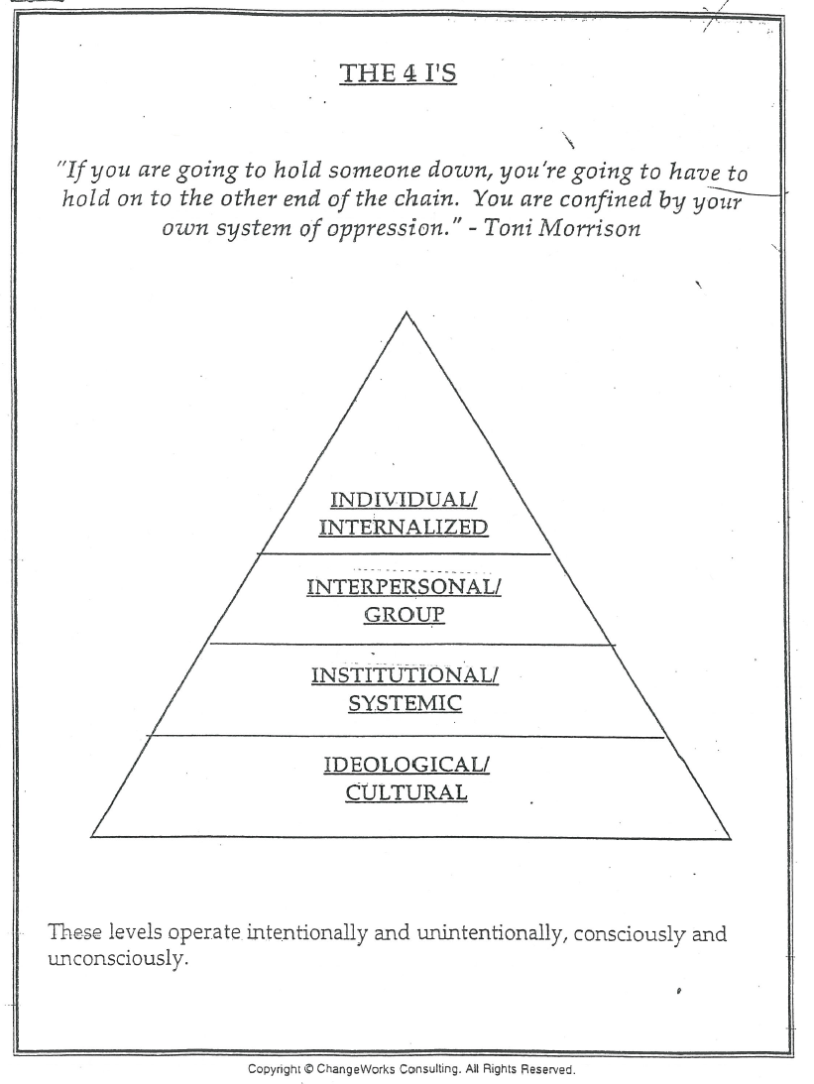
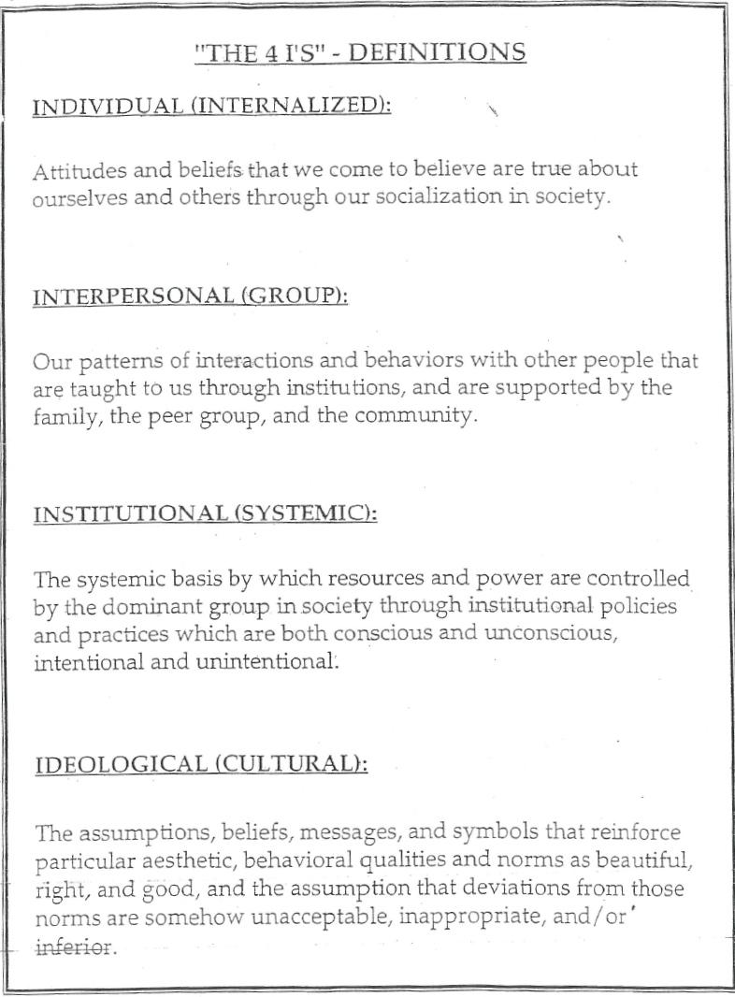

21-Day Racial Equity Habit Building Challenge
by Dr. Eddie Moore, Jr. & Debby Irving © America & Moore, LLC

You must be the change you wish to see in the world.” Mahatma “Gandhi

Have you ever made a successful change in your life? Perhaps you wanted to exercise more, eat less, or change jobs? Think about the time and attention you dedicated to the process. A lot, right? Change is hard. Creating effective social justice habits, particularly those dealing with issues of power, privilege and leadership is like any lifestyle change. Setting our intentions and adjusting what we spend our time doing is essential. It’s all about building new habits. Sometimes the hardest part it just getting started. We think understanding white privilege is a powerful lens into racism’s complexities. The good news is, there’s an abundance of resources just waiting to empower you to be a more effective player in the quest for racial justice.

The 21-Day Power, Privilege (White) and Leadership Skill Building Challenge is our way to support your effort to build your racial justice muscle. It’s simple: For 21 days, you do an action to further your connection to Power, Privilege (White) & Leadership concepts and networks. See some ideas below.

READ
Between the World and Me, by Ta-Nehisi Coates. A memoir written as a series of letters to his son. Raw and powerful storytelling illuminating the black American experience.
Birth of a White Nation: The Invention of White People and Its Relevance Today, by Jacqueline Battalora. An exploration of the moment in time when "white people," as a separate and distinct group of humanity, were invented through legislation and the enactment of laws.
Everyday White People Confront Racial and Social Injustice: 15 Stories, by Eddie Moore, Marguerite W. Penick-Parks & Ali Michael (Editors), Paul C. Gorski.(forward). 15 stories about what is entailed in developing a white anti-racist identity.
The New Jim Crow: Mass Incarceration in the Age of Colorblindness, by Michelle Alexander. An in-depth look at U.S. policies that target black men, rendingering the U.S. criminal justice system as a contemporary system of racial control.
Privilege, Power, and Difference, by Allan G. Johnson. An examination of systems of privilege and difference written in accessible, conversational language.
Waking Up White, and Finding Myself in the Story of Race, by Debby Irving. A brutally honest and engaging memoir exploring the way white people are socialized not to see or understand racism in their own lives. Inclu des end-of-chapter questions for self-reflection.
What White Children Need to Know About Race, Article exploring how not talking about race during childhood can leave white adults ill-equipped and fearful to talk about it as adults. Tips for how to get and keep the conversation going with children and beyond.

WATCH
Race: The Power of an Illusion Award-winning three-part documentary about the biology, politics, social construction, and lived experience of race.

I Am NOT Black, You are NOT White Prince Ea compares using skin color as a way to judge a person to using the one drives as a way to judge a person.
The Dog Whistle Politics of Race (Ian Haney Lopez with Bill Moyers) Part I and Part II. Interview exploring how post-civil-rights era language divides and deludes American citizens, effectively encouraging many to vote against their own interests.
Democracy in Black: How Race Still Enslaves the American Soul (Dr. Eddie Glaude, Jr. with Bill Moyers) Part I and Part II. Interview discussing Dr. Glaude’s exploration of the democratic party’s failure and his proposal to upend traditional politics with a “revolution of values.”
Test Your Awareness: Do The Test Once people start to learn about white privilege and America’s systems of oppression through history, often they ask, “Why didn’t I see this sooner?” It’s easy to overlook what we’re not looking for. Ask yourself what you have been looking for? What consumes your attention?
Park Avenue: Money, Power & The American Dream PBS film exploring wealth and power dynamics and examines why. Is the game rigged? Who notices? What makes addressing this issue as a society so fraught?
Unequal Opportunity Race Animated short illustrating the accumulated impact of white power and privilege.
What Would You Do? ABC’s popular show explores the impact of racial and gender bias and prejudice at a family friendly park. Before this video, would you have anticipated this differential treatment?
In The White Man's Image PBS documentary about the Indian boarding school movement designed to “kill the Indian and save the man.”

CONNECT
Like Facebook Pages of organizations who post daily about issues of power and privilege (TheRoot, RaceForward, Upworthy, Got Privilege?, Teaching Tolerance, BLM, Youth Action Project, & Moore)

Google who’s who in your area by typing in ‘Racial Justice (name of city/town). A few emails and phone calls later, you’ll likely have an idea of how to get on the mailing of one or more organizations in your area who are addressing issues of power and privilege.

Showing Up For Racial Justice (SURJ) organizes, mobilizes, and educates white people: See website here.

White People Challenging Racism (WPCR) education and resources. See website here.

ENGAGE
This can the hardest part for white people new to racial justice work. Engaging in racially mixed settings can trigger age-old power and privilege dynamics. The goal is to enter the process to learn and bridge knowledge gaps, not to take over, lead, and impose solutions. Be prepared to bring your humility with you!
- Stay engaged even when your mind and body start sending you signals to get small or walk away.
- Ask clarifying questions.
- Acknowledge what you don’t know.
- Journal to process emotions such as shame and anger that can guide you to deeper self-awareness about how power and privilege impacts you.
- Find a mentor within your own racial group to support and guide your growth.

ACT
Test yourself by taking Harvard’s free, online.Implicit Association Test (IAT),

Take a course or workshop. This one goes hand in hand with ‘Connect’ above. The network of people you discover may point you to a class, or finding a class first may point you to a network.

Prepare yourself to interrupt racial jokes. Click here for some advice about how.

Organize a film night or book group with family, friends, colleagues, or neighbors to learn and discuss together the dynamics and realities of privilege and power.

Attend an event in your area where issues of power and privilege are being addressed. Universities and bookstores often host speakers who draw the network you’ll want to plug into to keep engaged and motivated.
STAY INSPIRED!
Create a Social Justice Playlist that fuels you. Just a few ideas are:
Get Up, Stand Up / Bob Marley
Give Your Hands to Struggle / Sweet Honey in the Rock
Where Is The Love / Black Eyed Peas
White Privilege / Macklemore
White Privilege II / Macklemore
White Privilege 3 / Gyasi Ross
Super Rich Kids / Frank Ocean
Strength, Courage & Wisdom / India Arie
Whitey on the Moon / Gil Scott-Heron
Be Free / J Cole
The 10 Stop and Frisk Commandments / Jasiri X
Alexander Hamilton (sountrack) / Various Artists (sample here)
If It's Magic / Stevie Wonder
Same Love / Macklemore & Ryan Lewis
Keep Your Head Up / Tupac
Try / Colbie Caillat
Living for the City / Stevie Wonder
Fight the Power / Public Enemy
People Get Ready / Curtis Mayfield and The Impressions
And even Moore…

Gregory Porter - 1960 What?

Bitch Bad… Lupe Fiasco

Changes… 2Pac

For The Kids… Homeboy Sandman

Get Up, Stand Up… Bob Marley

Just Like You… Kevin So

Kill A Word… Eric Church
\
Man In The Mirror… Michael Jackson

Same Love… Macklemore

Strength, Courage & Wisdom… India Arie

Wanna Be Happy?... Kirk Franklin

Welcome to America… Lecrae

21-Day Racial Equity Habit Building Challenge
~ Keeping Track! Tip: diversify your habits by doing some of each

Day | Read | Watch | Connect | Engage | Act | Notes
1 |  |  |  |  |  | See sample below!
2
3
4
5
6
7
8
9
10
11
12
13
14
15
16
17
18
19
20
21

21-Day Racial Equity Habit Building Challenge (sample)

Day | Read | Watch | Connect | Engage | Act | Notes
1 | √ |  |  |  |  | Started Waking Up White
2 | √ |  |  |  |  | OMG, why didn’t I learn this stuff sooner??
3 |  | √ |  |  |  | Book mentioned True Colors. Found it online. Still true today?
4 |  |  | √ |  |  | Found Local Group. On mailing list, liked FB pg. 9/15 date!
5 | √ |  |  |  |  | Read local Group’s website. Couldn’t stop reading.
6 |  |  |  | √ |  | Attended Local Group film + discussion. Awesome people.
7 | √ | √ |  | √ |  | More I learn more I learn I don’t know. Want more, more, more!
8 |  |  |  | √ |  | 2nd day in a row I called a new Local Group connection for ideas.
9 | √ |  |  |  |  | Reading how to interrupt racist jokes. Do I dare? Feeling scared.
10 |  |  | √ |  |  | Liked three national racial justice organizations.
11 |  |  | √ |  | √ | Attended lecture by John Powell at Local U. Wow. Where have I been?
12 | √ | √ |  |  |  | New FB likes post amazing stuff. Feeling inspired!
13 | √ | √ | √ |  |  | Focused on whiteness in schools. So many orgs/resources. Who knew?
14 |  |  |  |  | √ | Called 5 friends for dinner + film. All psyched but John. Pissed me off!
15 | √ |  |  |  | √ | Read up on ways to address people like John. Called. Good-ish talk.
16 |  |  |  |  | √ | Signed up to take class at Local Community College.
17 |  |  |  | √ |  | Attended Local Group MeetUp. Talking Guidelines super helpful.
18 |  |  |  | √ |  | Met MeetUp friends for a beer. Went to part of town I’d never seen.
19 | √ |  |  |  |  | MeetUp friend loaned me Birth of a White Nation. Can’t put down.
20 |  |  | √ |  | √ | Hosted dinner + White Man’s Image film. Shocking, bonding, motivating.
21 |  |  |  |  | √ | Asked boss how to get on diversity committee. Want to join.

