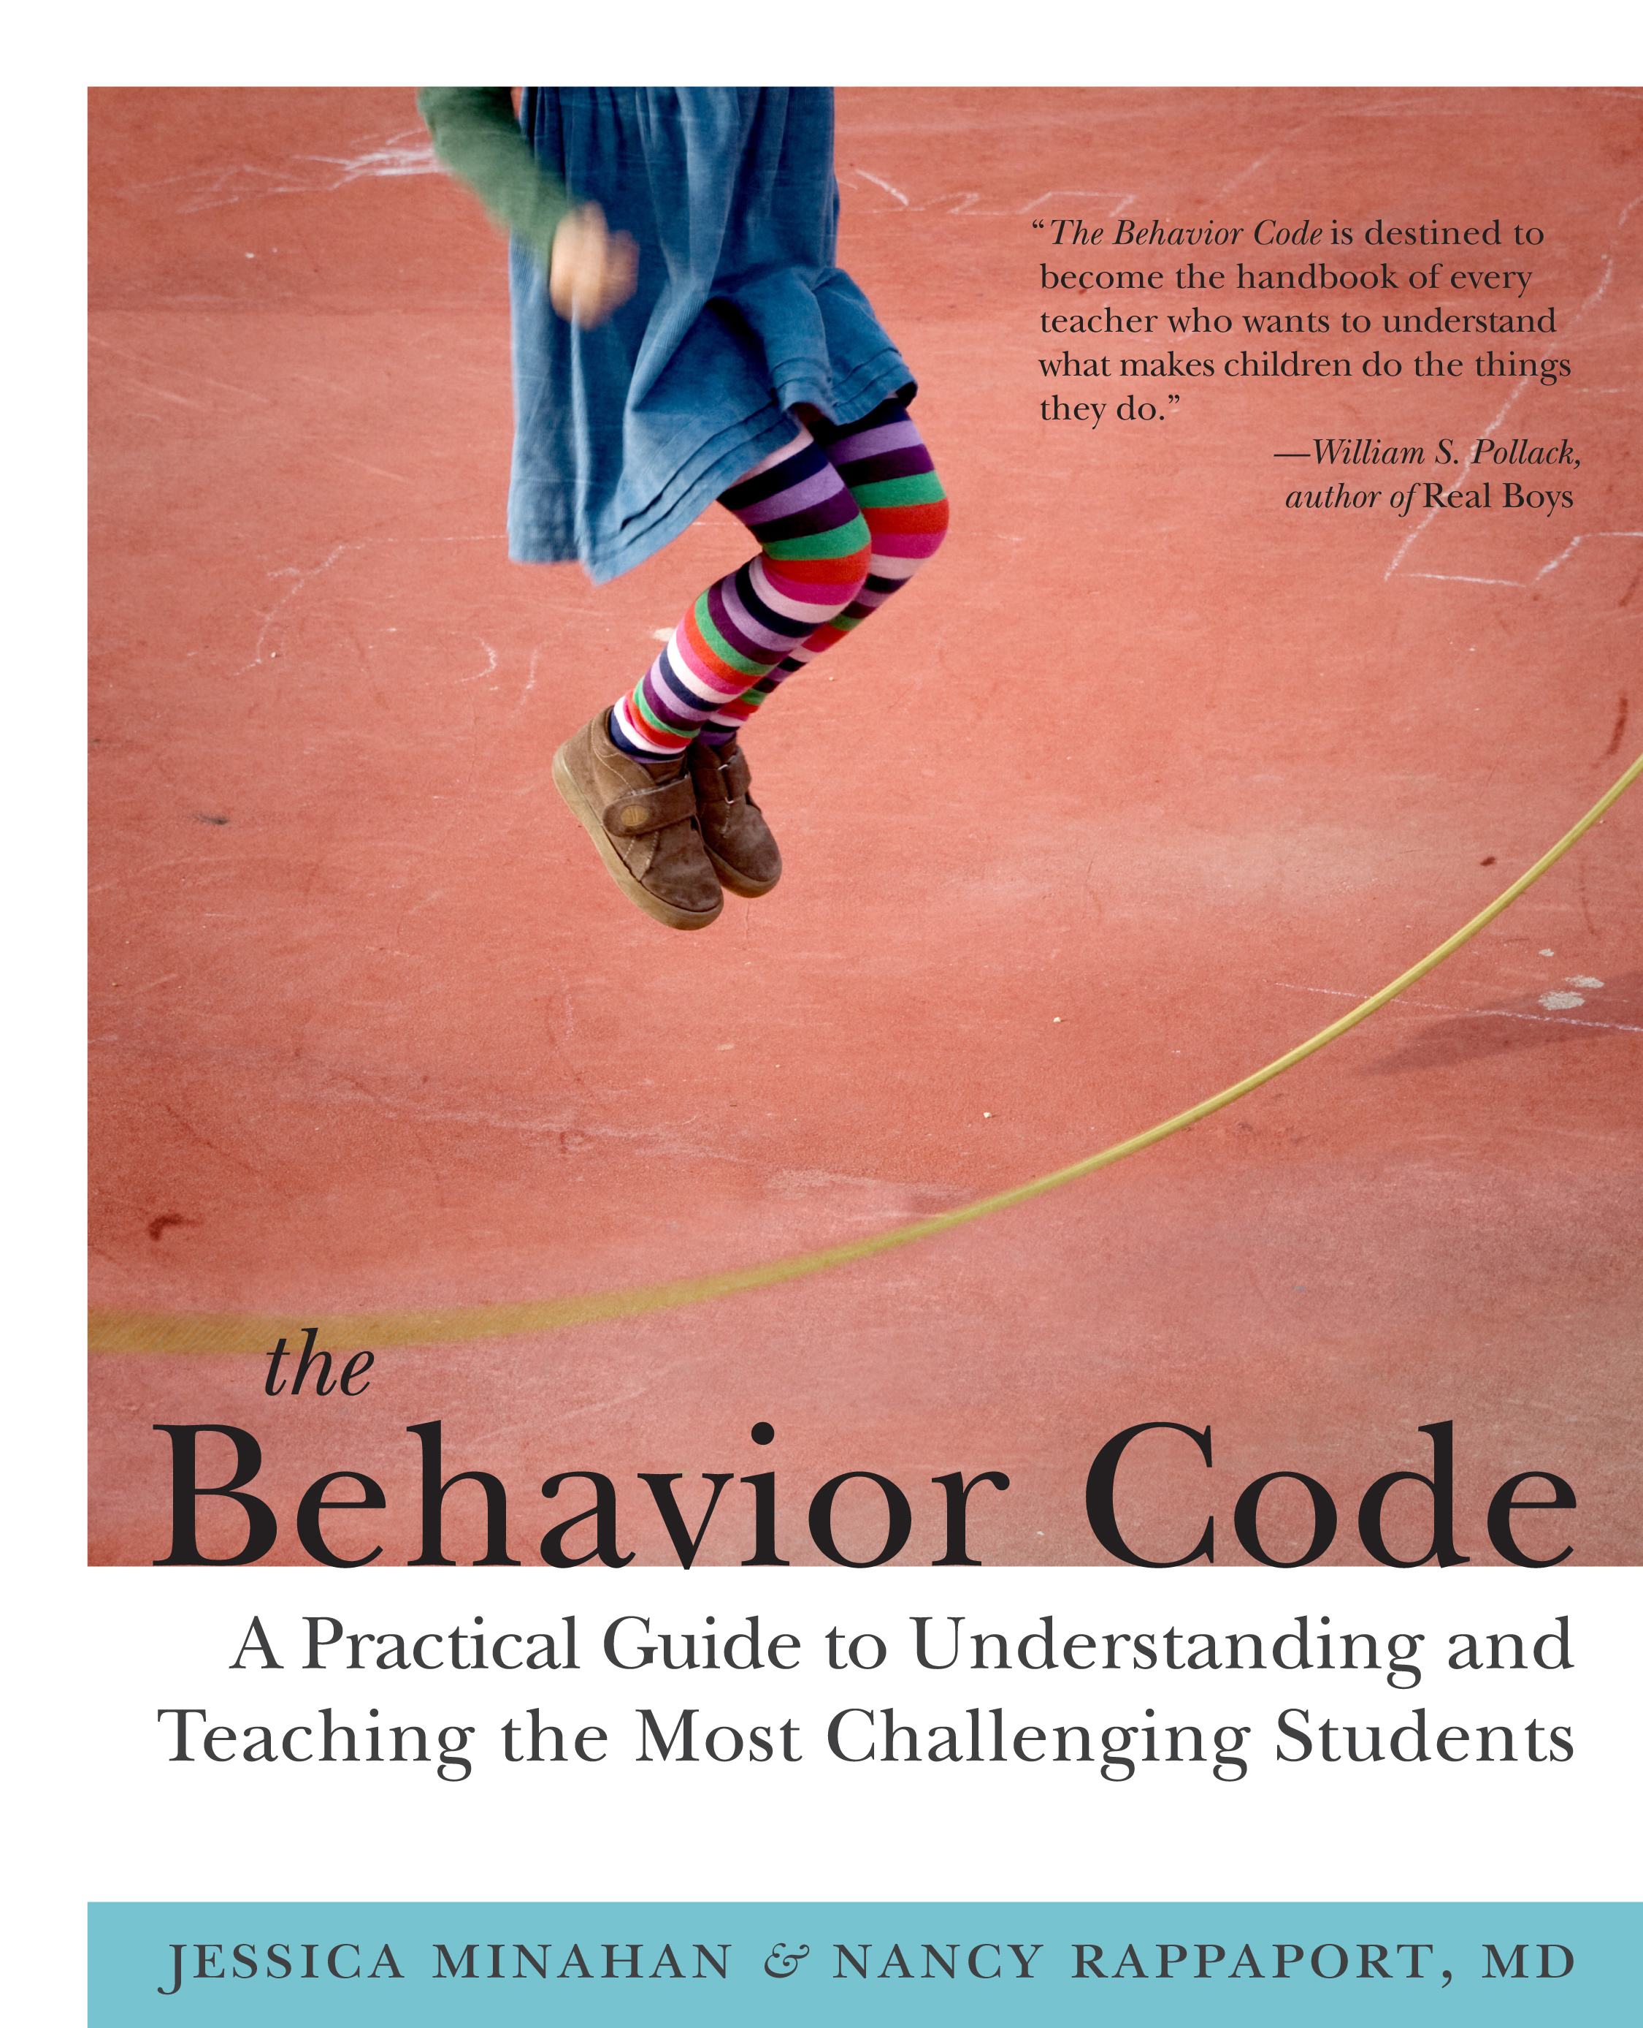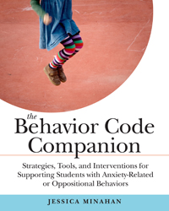

Reducing Anxiety and Disruptive Behavior in the Classroom

By Jessica Minahan, M.Ed, BCBA

With up to one in four children struggling with anxiety in this country, overwhelmed adults are in need of a new approach as well as an effective and easy-to-implement toolkit of strategies that work.
Through the use of case studies, humorous stories, and examples of common challenging situations, participants will learn easy to implement preventive tools, strategies, and interventions for reducing anxiety, increasing self-regulation, work engagement, and self-monitoring.

Bio:
Jessica Minahan, MEd, BCBA, is a licensed and board certified behavior analyst and
special educator, as well as a consultant to school’s nationwide (www.jessicaminahan.com). Jessica has over seventeen years of experience supporting students who exhibit challenging behavior in urban public school systems. She is a blogger on The Huffington Post, as well as the author of The Behavior Code: A Practical Guide to Understanding and Teaching the Most Challenging Students, with Nancy Rappaport (Harvard Education Press, 2012) and author of The Behavior Code Companion: Strategies, Tools, and Interventions for Supporting Students with Anxiety-Related or Oppositional Behaviors (Harvard Education Press, 2014).

